CHINESE FLAGSHIP SECONDARY CURRICULUM
Level 1, Unit 4: At School
Assessment: INTERPERSONAL SPEAKING
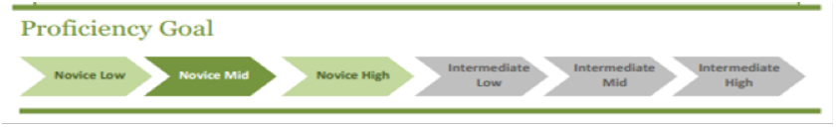
Scenario 1- Interpersonal Speaking | Objective
Scenario 1:  Before school starts, you go to the book store to buy your school supplies and you get some help from the book store clerk. Follow the guide below to have your conversation with the clerk.  Student A (Customer)  • Ask the store clerk if they carry certain school supplies.  • Answer the clerk’s questions.  • Ask about another item.  • Tell the store clerk you like this store and will come again.  • Say you’re welcome and see you again.  B (Store Clerk)  • Respond to the customer’s questions, and ask what color does he/she like.  • Respond to the customer’s questions, and ask the quantity he/she needs. Then ask if he/she needs anything else.  • Repeat the items and quantities.  • Say thank you and see you again. | I can make requests of and ask questions about stationary with a proper manner.

Scenario 3- Presentational Speaking | Objective
Scenario 2:  You are assigned as “school ambassador” to welcome a group of high school students from China. They are here to learn about American high school student’s life and would like to know about courses and class schedule because they may come to U.S. for a year or two as exchange students.  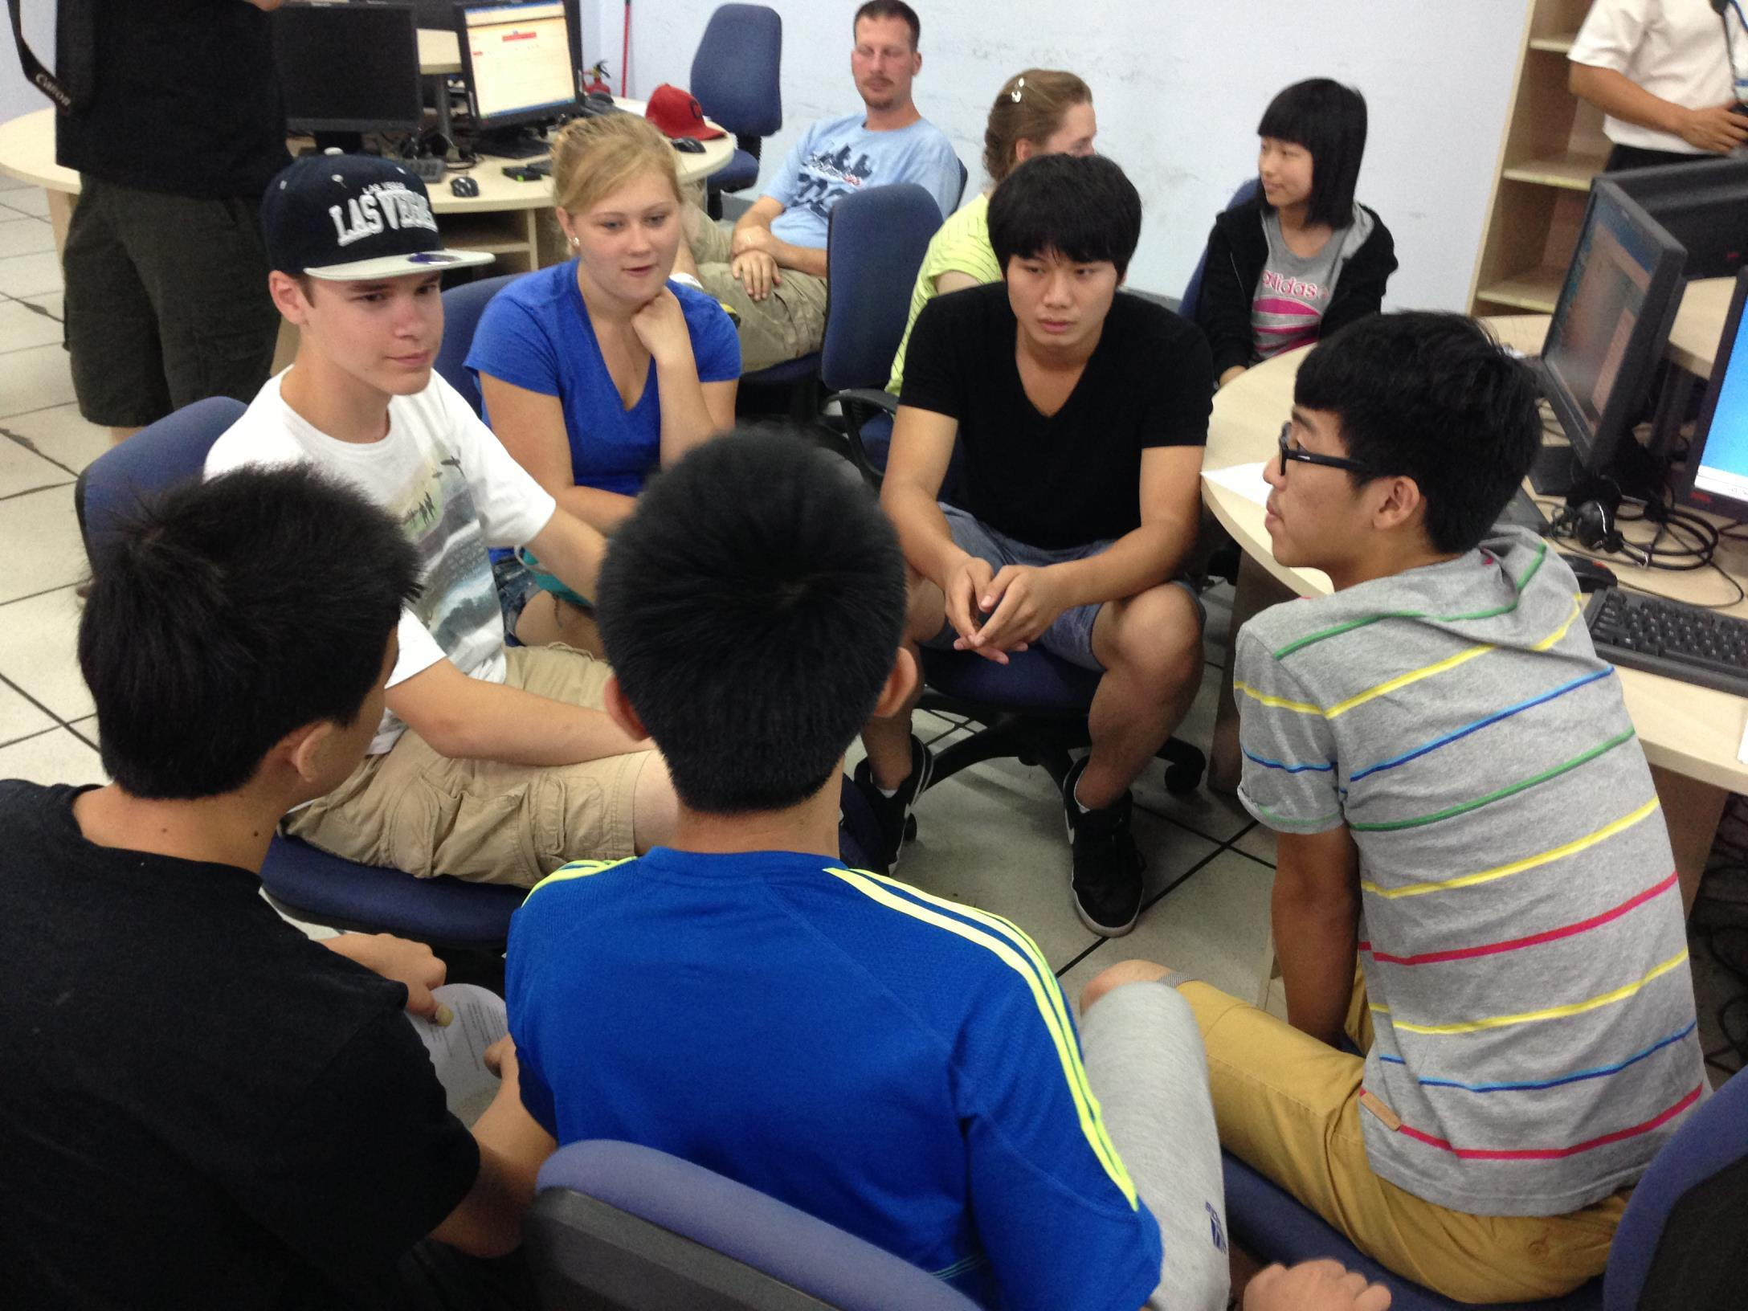  - Properly introduce yourself with your name, age, and grade level.  - Tell them your daily schedule with details, including times and rooms.  - Talk about your favorite classes and classes that you struggle.  - Ask if they are interested in some subjects and if they feel some subjects difficult. | I can talk about my school schedule and my favorite subjects.  I can explain my school schedule with time and place details.

